

Homework - 3

Last 4 digit : 4767

CSCI 331 33

5/20/18



1. Increase the price of acetaminophen by 10% for only stores in NY. Identify the SQL required to implement. Display the price before and after the price increase.

select name, to_char(store_drugs.price, '$9,999.99') price, to_char(store_drugs.price*1.1, '$9,999.99') Updated_Price

from drugs, store_drugs

where drugs.did=store_drugs.did and

name='Acetaminophen'

and store_drugs.stid in(

select stid

from stores

where stores.city='Flushing'

);

update store_drugs

set price = price *1.1

where store_drugs.did in (

select drugs.did

from drugs

where drugs.name = 'Acetaminophen'

)

and store_drugs.stid in (

select stores.stid

from stores

where state = 'NY');

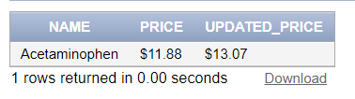

2. Identify drugs that have not been purchased this month. Display the drug name. Use a nested select to answer this question.

|  |  |
| --- | --- |
| select drugs.name, did  from drugs  where drugs.did not in(  select did  from Transaction_items  where tid in(  select tid  from transactions  where transactions.tdate > '4/18/2018')); |  |

3. Reassign employee Joe Smith from the Kew Gardens store to the Flushing store. Identify the SQL required to implement.

update staff_store

set stid = (

select stid

from stores

where city='Flushing')

where sid = (

select sid

from staffs

where first = 'Joe'

and last = 'Smith' );

commit;

4. The drug acetaminophen will no longer be sold at any store. Identify the SQL required to implement.

alter table store_drugs

add availability char(1);

update store_drugs

set availability = 'Y'

where stocks >0;

alter table "STORE_DRUGS"

modify AVAILABILITY CHAR(1) NOT NULL;

update store_drugs

set availability = 'N'

where did in (

select did

from drugs

where name = 'Acetaminophen');

commit;

5. In one SQL window, change the address of CVS employee Joe Smith. Don’t

commit. In another SQL window, change the first name for CVS employee Joe

Smith. Don’t commit. Explain your results. Resolve the problem. Disable the auto commit flag at the top of the window before performing this operation.

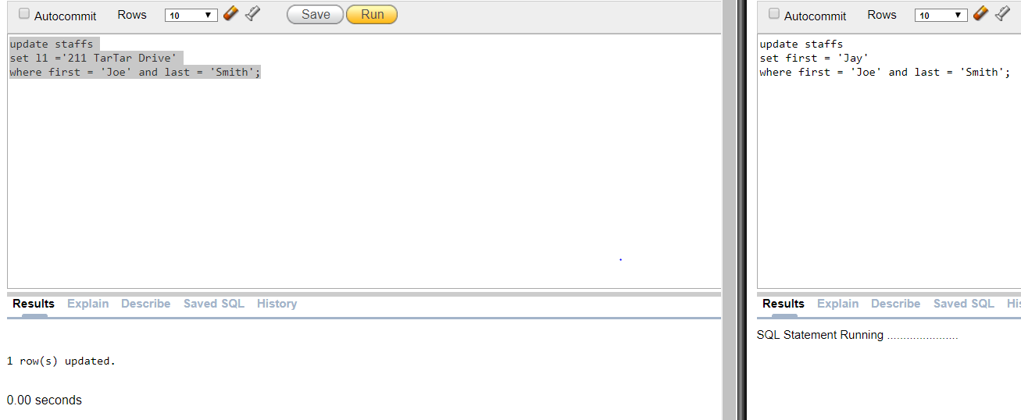

This is because one of the user is still working on the table and doing so, the table is lock until it is committed. Then the second user may make changes to table.

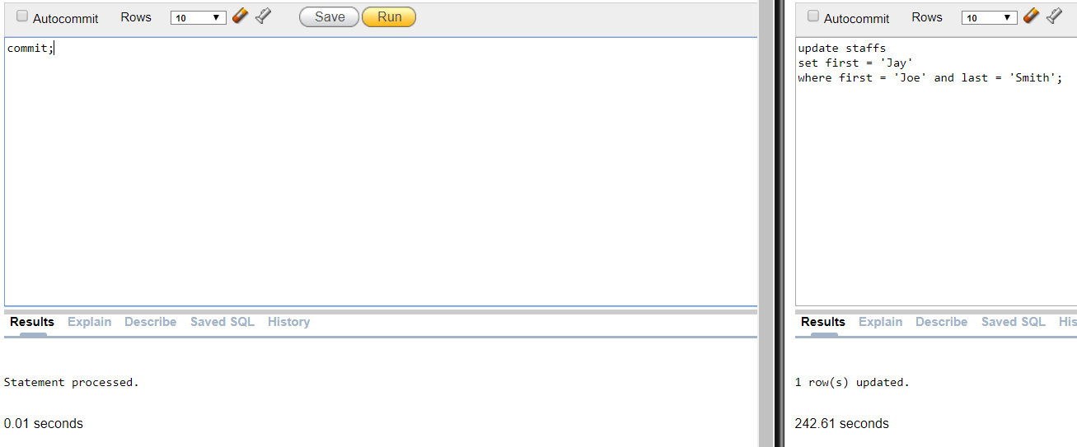

Commit;

6. In one SQL window, delete all products. Don’t commit. In another SQL window increase the price of all products by 10%. Explain your results. Resolve the problem.

|  |  |
| --- | --- |
|  |  |

Similar to problem 6, the increase will halt due to the table being lock. The increase will not work. Since we want to increase the price for drugs, we will have to rollback the delete command. After doing so, the update of drug price will process.

7. In one SQL window, change the salary for employee Jose Lebron. Don't commit. In another SQL window, change the last name of employee Jose Lebron Don’t commit. Quit both Oracle sessions. Login to Oracle and display all information for the employee Jose Lebron. Explain your results. Disable the auto commit flag at the top of the windows before performing this operation.

Because we didn’t commit, the salary and last time will still be the same. Always commit before exit.

8. Use the SQL DESCRIBE operation to display the structure for all tables.

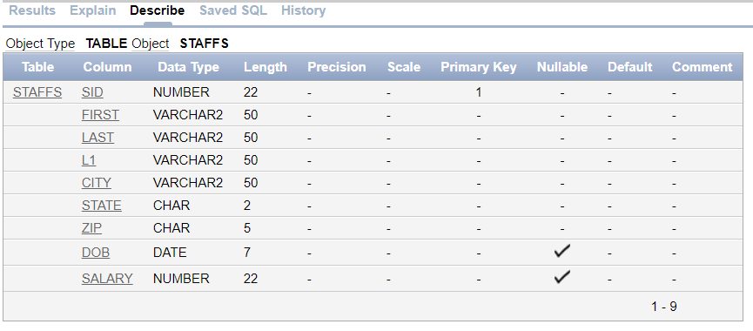

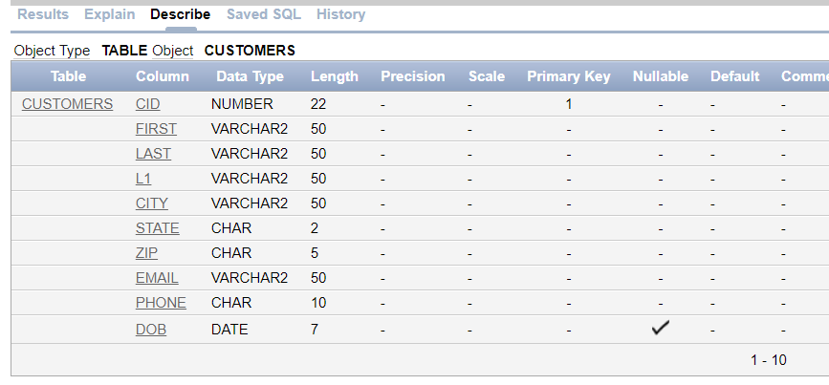

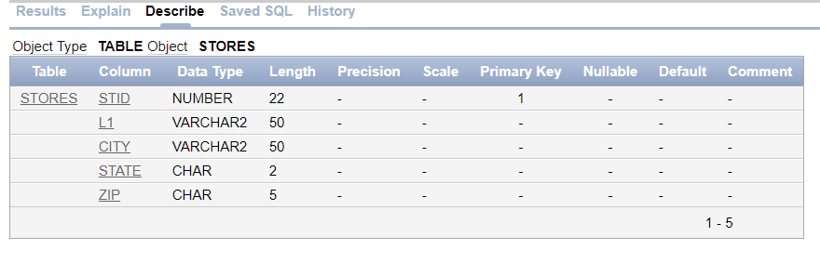 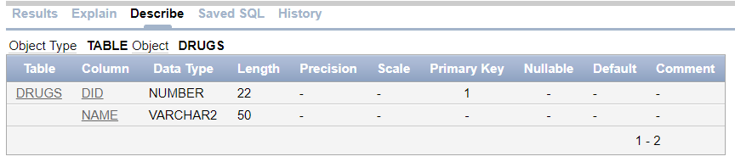

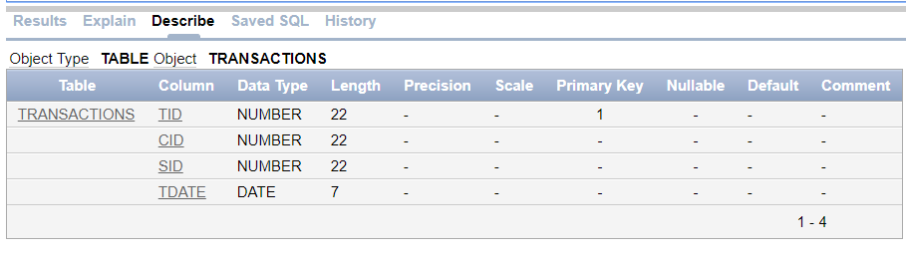

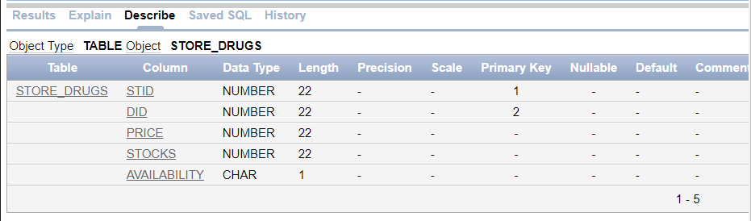

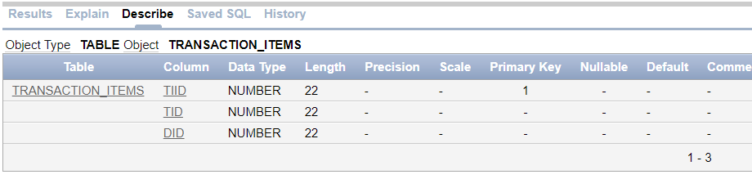 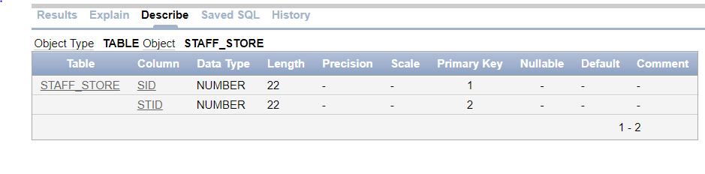

9. Display the Oracle version by entering

select *

from product_component_version;

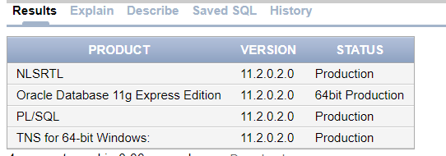

Create table

create table customers (

CID number primary key,

first varchar(50) not null,

last varchar(50) not null,

L1 varchar(50) not null,

city varchar(50) not null,

state char(2) not null,

zip char(5) not null,

email varchar(50) not null,

phone char(10) not null,

DOB date not null

);

create table staffs (

SID number primary key,

first varchar(50) not null,

last varchar(50) not null,

L1 varchar(50) not null,

city varchar(50) not null,

state char(2) not null,

zip char(5) not null

DOB date not null

);

create table stores (

STID number primary key,

L1 varchar(50) not null,

city varchar(50) not null,

state char(2) not null,

zip char(5) not null

);

create table Drugs(

DID number primary key,

name varchar(50) not null

);

create table Transactions (

TID number primary key,

CID number not null,

SID number not null,

tdate date not null,

foreign key (CID) references customers(CID),

foreign key (SID) references staffs(SID),

foreign key (STID) references stores(STID)

);

create table store_drugs(

stid number not null,

did number not null,

price number not null,

Stocks number not null,

primary key (stid,did));

Create table Transaction_items(

TIID number primary key,

TID number not null,

DID number not null,

foreign key (TID) references Transactions (TID),

foreign key (DID) references Drugs(DID)

);

create table staff_store(

SID number,

STID number,

primary key (SID,STID),

foreign key (SID) references staffs(SID),

foreign key (STID) references stores(STID)

);

CREATE SEQUENCE drugs_id_seq

MINVALUE 1

START WITH 1

INCREMENT BY 1;

CREATE SEQUENCE customers_id_seq

MINVALUE 1

START WITH 1

INCREMENT BY 1;

INSERT

insert into customers values(customers_id_seq.nextval, 'Denise', 'Young', '725 Evergreen Ave', 'Brooklyn', 'NY', '11207', 'ramollin@aol.com', '6163968539', '03/05/1992');

insert into customers values(customers_id_seq.nextval, 'Kate', 'Chapman', '40 W 86th St', 'New York', 'NY', '10024', 'burniske@gmail.com', '2127213922', '12/14/1958');

insert into customers values(customers_id_seq.nextval, 'Angel', 'Kim', '14953 Elm Ave', 'Flushing', 'NY', '11355', 'zyghom@optonline.net', '6074454010', '10/24/1976');

insert into customers values(customers_id_seq.nextval, 'Ralph', 'Joson', '4515 Colden St #4E', 'Flushing', 'NY', '11355', 'sagal@comcast.net', '4402936421', '03/16/1968');

insert into customers values(customers_id_seq.nextval, 'Tammy', 'Turner', '418 W 130th St #61', 'New York', 'NY', '10027', 'sethbrown@mac.com', '3027311010', '05/23/1973');

insert into customers values(customers_id_seq.nextval, 'Henry', 'Lee', '17212 133rd Ave', 'Jamaica', 'NY', '11434', 'ahmad@yahoo.com', '7724614276', '07/31/1988');

insert into customers values(customers_id_seq.nextval, 'Walter', 'White', '157-18 59th Ave', 'Midtown', 'NY', '11434', 'mxiao@sbcglobal.net', '4536375857', '01/26/1950');

insert into customers values(customers_id_seq.nextval, 'Terry', 'Mo', '12314 113rd Ave', 'Jamaica', 'NY', '11252', 'sdfasa@yahoo.com', '7724614276', '09/16/1969');

insert into customers values(customers_id_seq.nextval, 'Jessy', 'Jones', '157-22 30th Ave', 'Midtown', 'NY', '11334', 'sdfssss@sbcglobal.net', '4536375857', '03/05/1991');

insert into drugs values(drugs_id_seq.nextval, 'Hydrocodone');

insert into drugs values(drugs_id_seq.nextval, 'Advil');

insert into drugs values(drugs_id_seq.nextval, 'Amoxicillin');

insert into drugs values(drugs_id_seq.nextval, 'Ampyra');

insert into drugs values(drugs_id_seq.nextval, 'Antihistamines');

insert into drugs values(drugs_id_seq.nextval, 'Azithromycin');

insert into drugs values(drugs_id_seq.nextval, 'Ciprofloxacin');

insert into drugs values(drugs_id_seq.nextval, 'Flagyl');

insert into drugs values(drugs_id_seq.nextval, 'Focalin');

insert into drugs values(drugs_id_seq.nextval, 'Hydrocortisone');

insert into drugs values(drugs_id_seq.nextval, 'Invokana');

insert into drugs values(drugs_id_seq.nextval, 'Meloxicam');

insert into drugs values(drugs_id_seq.nextval, 'Prilosec');

insert into drugs values(drugs_id_seq.nextval, 'Relenza');

insert into drugs values(drugs_id_seq.nextval, 'Rheumatrex');

insert into drugs values(drugs_id_seq.nextval, 'Stelara');

insert into drugs values(drugs_id_seq.nextval, 'Ultram');

insert into drugs values(drugs_id_seq.nextval, 'Vicodin');

insert all

into stores values(1 ,'31 Saint Johns Pl','Brooklyn','NY','11217')

into stores values(2 ,'14953 Elm Ave','Flushing','NY','11355')

into stores values(3 ,'13610 Latimer Pl','Flushing','NY','11354')

into stores values(4 ,'13627 58th Ave','Brooklyn','NY','11217')

into stores values(5 ,'2105 Painted Post Dr',' Bronx','NY','11507')

select * from dual;

insert all

into Staffs values(1, 'Mareli', 'Brooks', '4332 Kissena Blvd #APT 5N', 'Flushing', 'NY', '11355', '08/29/1993')

into Staffs values(2, 'Clayton', 'Shea', '14953 Elm Ave', 'Flushing', 'NY', '11355', '10/27/1957')

into Staffs values(3, 'Asia', 'Mcdonald', '4515 Colden St #4E', 'Flushing', 'NY', '11355', '09/12/1961')

into Staffs values(4, 'Jax', 'Francis', '848 E 28th St', 'Brooklyn', 'NY', '11224', '08/20/1980')

into Staffs values(5, 'Taylor', 'Chavez', '2944 W 5th St', 'Brooklyn', 'NY', '11210', '06/19/1977')

into Staffs values(6, 'Natasha', 'Walters', '155 E 29th St', 'New York', 'NY', '10027', '10/03/1971')

into Staffs values(7, 'Aniya', 'Levy', '10 W 138th St #APT 3G', 'New York', 'NY', '10037', '08/12/1990')

select * from dual;

insert all

into staff_store values (1,1)

into staff_store values (2,2)

into staff_store values (3,3)

into staff_store values (4,4)

into staff_store values (5,5)

into staff_store values (6,1)

into staff_store values (7,2)

select * from dual;

insert all

into Transactions values (1,1,1,'2/17/2017')

into Transactions values (2,2,5,'3/2/2017')

into Transactions values (3,3,4,'2/24/2017')

into Transactions values (4,4,1,'3/14/2017')

into Transactions values (5,5,6,'4/21/2017')

into Transactions values (6,6,4,'6/26/2017')

into Transactions values (7,7,1,'6/27/2017')

into Transactions values (8,8,3,'6/29/2017')

into Transactions values (9,9,5,'6/29/2017')

into Transactions values (10,1,5,'7/19/2017')

into Transactions values (11,2,3,'8/9/2017')

into Transactions values (12,3,7,'8/18/2017')

into Transactions values (13,4,1,'1/12/2018')

into Transactions values (14,5,3,'1/12/2018')

into Transactions values (15,6,4,'1/12/2018')

into Transactions values (16,7,1,'3/22/2018')

into Transactions values (17,8,7,'3/22/2018')

into Transactions values (18,9,6,'3/22/2018')

into Transactions values (19,1,6,'5/8/2018')

into Transactions values (20,2,1,'5/8/2018')

into Transactions values (21,3,7,'5/8/2018')

into Transactions values (22,4,7,'5/21/2018')

into Transactions values (23,5,1,'5/21/2018')

into Transactions values (24,6,4,'5/21/2018')

into Transactions values (25,7,3,'5/31/2018')

into Transactions values (26,8,2,'5/31/2018')

into Transactions values (27,9,4,'5/31/2018')

into Transactions values (28,1,3,'4/25/2018')

into Transactions values (29,2,4,'4/25/2018')

into Transactions values (30,4,2,'2/9/2018')

select * from dual;

insert all

into Transaction_items values (1,1,)

into Transaction_items values (2,1,)

into Transaction_items values (3,2,)

into Transaction_items values (4,2,)

into Transaction_items values (5,3,)

into Transaction_items values (6,3,)

into Transaction_items values (7,3)

into Transaction_items values (8,4)

into Transaction_items values (9,5)

into Transaction_items values (10,6)

into Transaction_items values (11,8)

into Transaction_items values (12,9)

into Transaction_items values (13,10)

into Transaction_items values (14,11)

into Transaction_items values (15,12)

into Transaction_items values (16,13)

into Transaction_items values (17,14)

into Transaction_items values (18,15)

into Transaction_items values (19,16)

into Transaction_items values (20,17)

into Transaction_items values (21,18)

into Transaction_items values (22,19)

into Transaction_items values (23,19)

into Transaction_items values (24,20)

into Transaction_items values (25,21)

into Transaction_items values (26,22)

into Transaction_items values (27,23)

into Transaction_items values (28,24)

into Transaction_items values (29,25)

into Transaction_items values (20,25)

into Transaction_items values (31,26)

into Transaction_items values (32,27)

into Transaction_items values (33,27)

into Transaction_items values (34,28)

into Transaction_items values (35,29)

into Transaction_items values (36,29)

into Transaction_items values (37,30)

into Transaction_items values (38,30)

into Transaction_items values (39,30)

into Transaction_items values (40,30)

select * from dual;

insert all

into store_drugs values(1,1,12,15)

into store_drugs values(1,2,17,15)

into store_drugs values(1,3,20,15)

into store_drugs values(1,4,30,15)

into store_drugs values(1,5,15,15)

into store_drugs values(1,6,16,15)

into store_drugs values(1,7,26,15)

into store_drugs values(1,8,35,15)

into store_drugs values(1,9,40,15)

into store_drugs values(1,10,60,15)

into store_drugs values(1,11,10,15)

into store_drugs values(1,12,12,15)

into store_drugs values(1,13,13,15)

into store_drugs values(1,14,6,15)

into store_drugs values(1,15,16,15)

into store_drugs values(1,16,27,15)

into store_drugs values(1,17,84,15)

into store_drugs values(1,18,9,15)

into store_drugs values(2,1,12,15)

into store_drugs values(2,2,17,15)

into store_drugs values(2,3,20,15)

into store_drugs values(2,4,30,15)

into store_drugs values(2,5,15,15)

into store_drugs values(2,6,16,15)

into store_drugs values(2,7,26,15)

into store_drugs values(2,8,35,15)

into store_drugs values(2,9,40,15)

into store_drugs values(2,10,60,15)

into store_drugs values(2,11,10,15)

into store_drugs values(2,12,12,15)

into store_drugs values(2,13,13,15)

into store_drugs values(2,14,6,15)

into store_drugs values(2,15,16,15)

into store_drugs values(2,16,27,15)

into store_drugs values(2,17,84,15)

into store_drugs values(2,18,9,15)

into store_drugs values(3,1,12,15)

into store_drugs values(3,2,17,15)

into store_drugs values(3,3,20,15)

into store_drugs values(3,4,30,15)

into store_drugs values(3,5,15,15)

into store_drugs values(3,6,16,15)

into store_drugs values(3,7,26,15)

into store_drugs values(3,8,35,15)

into store_drugs values(3,9,40,15)

into store_drugs values(3,10,60,15)

into store_drugs values(3,11,10,15)

into store_drugs values(3,12,12,15)

into store_drugs values(3,13,13,15)

into store_drugs values(3,14,6,15)

into store_drugs values(3,15,16,15)

into store_drugs values(3,16,27,15)

into store_drugs values(3,17,84,15)

into store_drugs values(3,18,9,15)

into store_drugs values(4,1,12,15)

into store_drugs values(4,2,17,15)

into store_drugs values(4,3,20,15)

into store_drugs values(4,4,30,15)

into store_drugs values(4,5,15,15)

into store_drugs values(4,6,16,15)

into store_drugs values(4,7,26,15)

into store_drugs values(4,8,35,15)

into store_drugs values(4,9,40,15)

into store_drugs values(4,10,60,15)

into store_drugs values(4,11,10,15)

into store_drugs values(4,12,12,15)

into store_drugs values(4,13,13,15)

into store_drugs values(4,14,6,15)

into store_drugs values(4,15,16,15)

into store_drugs values(4,16,27,15)

into store_drugs values(4,17,84,15)

into store_drugs values(4,18,9,15)

into store_drugs values(5,1,12,15)

into store_drugs values(5,2,17,15)

into store_drugs values(5,3,20,15)

into store_drugs values(5,4,30,15)

into store_drugs values(5,5,15,15)

into store_drugs values(5,6,16,15)

into store_drugs values(5,7,26,15)

into store_drugs values(5,8,35,15)

into store_drugs values(5,9,40,15)

into store_drugs values(5,10,60,15)

into store_drugs values(5,11,10,15)

into store_drugs values(5,12,12,15)

into store_drugs values(5,13,13,15)

into store_drugs values(5,14,6,15)

into store_drugs values(5,15,16,15)

into store_drugs values(5,16,27,15)

into store_drugs values(5,17,84,15)

into store_drugs values(5,18,9,15)

select * from dual;

update table

update drugs

set name = 'Acetaminophen'

where did= 1;

update store_drugs

set price = price*.9

where stid =2;

update store_drugs

set price = price*1.1

where stid =3;

update store_drugs

set price = price*1.4

where stid =4;

update store_drugs

set price = price*.85

where stid = 5;

update stores

set l1 = '81-29 Lefferts Blvd' ,

city = 'Kew Gardens' ,

zip = 11415

where stid = 3;

update staffs

set first = 'Joe',

last = 'Smith'

where sid = 7;

alter table staffs

add salary number;

update staffs

set salary = 20000;

commit;

CREATE TABLE back_up_customers

AS SELECT *

FROM customers ;

commit;

CREATE TABLE back_up_staffs

AS SELECT *

FROM staffs ;

CREATE TABLE back_up_Transactions

AS SELECT *

FROM Transactions ;

CREATE TABLE back_up_stores

AS SELECT *

FROM stores ;

CREATE TABLE back_up_drugs

AS SELECT *

FROM drugs;

Commit;